Frequencies

Notes
Output Created |  | 21-OCT-2022 20:11:52
Comments
Input | Data | C:\Users\ABDIRIZAK\Desktop\ABDIRIZAK.sav
Input | Active Dataset | DataSet0
Input | Filter | <none>
Input | Weight | <none>
Input | Split File | <none>
Input | N of Rows in Working Data File | 10
Missing Value Handling | Definition of Missing | User-defined missing values are treated as missing.
Missing Value Handling | Cases Used | Statistics are based on all cases with valid data.
Syntax |  | FREQUENCIES VARIABLES=Gender Age Occupation Relationship Region Station NSSF_Ofiice_Distribution Registration_process Modes_of_contribution NSSF_Affordability_contribution Sufficient_income_contributions NSSF_Safety_Contributions Investment_by_NSSF  NSSF_Benefits NSSF_Rules_and_Decisions No_Corruption_in_NSSF Good_Delivery_Service Responsible_and_Openly_Staff NSSF_Staff_Teamwork  /BARCHART FREQ  /ORDER=VARIABLE.
Resources | Processor Time | 00:00:02.19
Resources | Elapsed Time | 00:00:02.38

The Gender of the customers

Statistics
The Gender of the customers
N | Valid | 10
N | Missing | 0

The Gender of the customers
 |  | Frequency | Percent | Valid Percent | Cumulative Percent
Valid | Male | 4 | 40.0 | 40.0 | 40.0
Valid | Female | 6 | 60.0 | 60.0 | 100.0
Valid | Total | 10 | 100.0 | 100.0

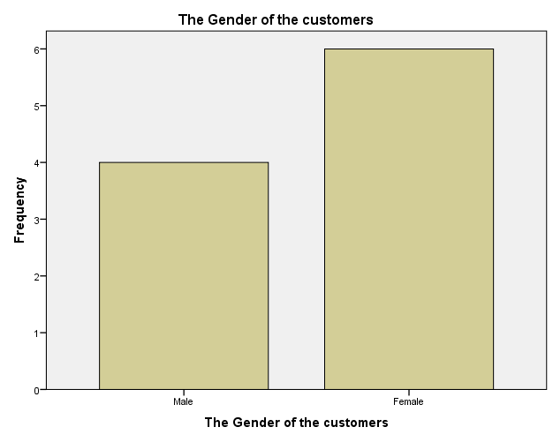

The Age of the customers

Statistics
The Age of the customers
N | Valid | 10
N | Missing | 0

The Age of the customers
 |  | Frequency | Percent | Valid Percent | Cumulative Percent
Valid | 18-24 | 2 | 20.0 | 20.0 | 20.0
Valid | 25-34 | 3 | 30.0 | 30.0 | 50.0
Valid | 35-44 | 2 | 20.0 | 20.0 | 70.0
Valid | 45-54 | 2 | 20.0 | 20.0 | 90.0
Valid | 55+ | 1 | 10.0 | 10.0 | 100.0
Valid | Total | 10 | 100.0 | 100.0

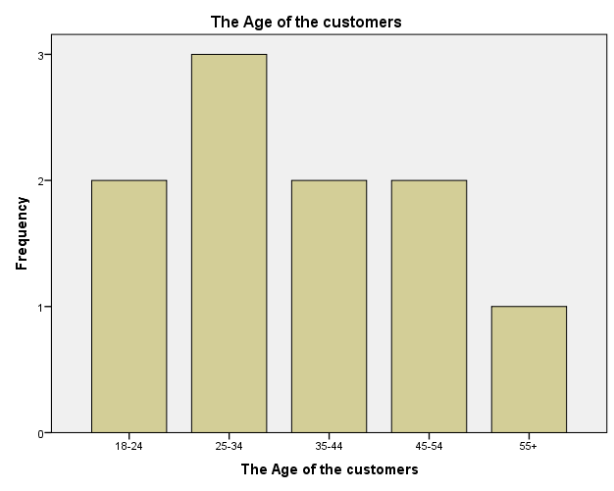

The Customers occupation

Statistics
The Customers occupation
N | Valid | 10
N | Missing | 0

The Customers occupation
 |  | Frequency | Percent | Valid Percent | Cumulative Percent
Valid | Employed | 5 | 50.0 | 50.0 | 50.0
Valid | Self Employed | 3 | 30.0 | 30.0 | 80.0
Valid | Claimant | 2 | 20.0 | 20.0 | 100.0
Valid | Total | 10 | 100.0 | 100.0

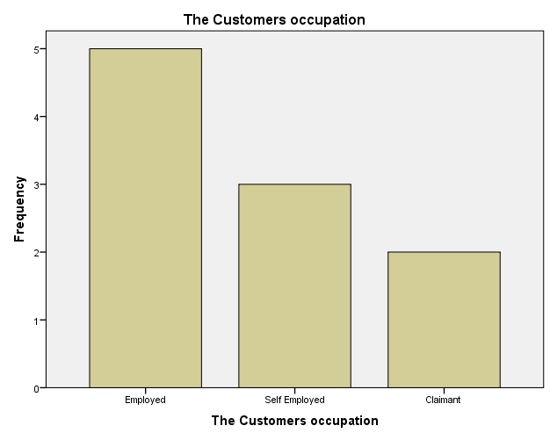

The Customers claimant

Statistics
The Customers claimant
N | Valid | 10
N | Missing | 0

The Customers claimant
 |  | Frequency | Percent | Valid Percent | Cumulative Percent
Valid | Self | 4 | 40.0 | 40.0 | 40.0
Valid | Family Member | 2 | 20.0 | 20.0 | 60.0
Valid | Friend | 4 | 40.0 | 40.0 | 100.0
Valid | Total | 10 | 100.0 | 100.0

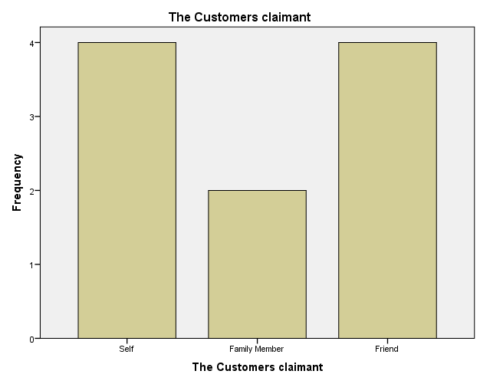

The Customers location

Statistics
The Customers location
N | Valid | 10
N | Missing | 0

The Customers location
 |  | Frequency | Percent | Valid Percent | Cumulative Percent
Valid | Nairobi | 1 | 10.0 | 10.0 | 10.0
Valid | Rift Valley | 1 | 10.0 | 10.0 | 20.0
Valid | Central | 2 | 20.0 | 20.0 | 40.0
Valid | Nyanza | 2 | 20.0 | 20.0 | 60.0
Valid | North Eastern | 2 | 20.0 | 20.0 | 80.0
Valid | Coast | 2 | 20.0 | 20.0 | 100.0
Valid | Total | 10 | 100.0 | 100.0

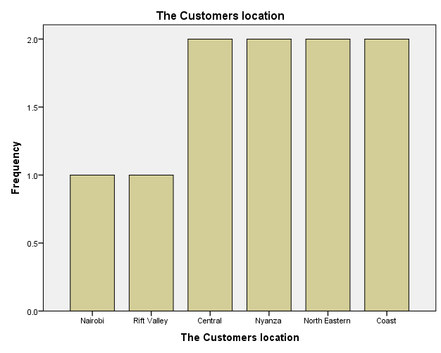

NSSF Branches

Statistics
NSSF Branches
N | Valid | 10
N | Missing | 0

NSSF Branches
 |  | Frequency | Percent | Valid Percent | Cumulative Percent
Valid | Kiambu Branch | 2 | 20.0 | 20.0 | 20.0
Valid | Hill Branch | 2 | 20.0 | 20.0 | 40.0
Valid | Donholm Branch | 2 | 20.0 | 20.0 | 60.0
Valid | Ongata Rongai Branch | 2 | 20.0 | 20.0 | 80.0
Valid | Nairobi Branch | 2 | 20.0 | 20.0 | 100.0
Valid | Total | 10 | 100.0 | 100.0

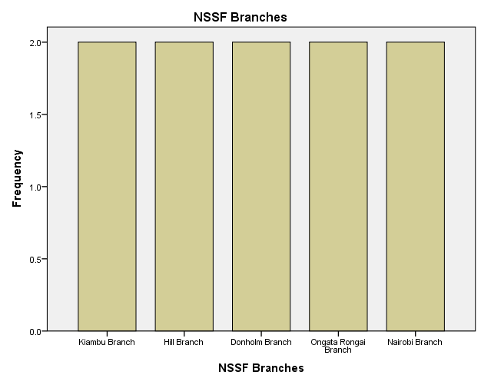

Customers who are satisfied with the disribution of NSSF offices

Statistics
Customers who are satisfied with the disribution of NSSF offices
N | Valid | 10
N | Missing | 0

Customers who are satisfied with the disribution of NSSF offices
 |  | Frequency | Percent | Valid Percent | Cumulative Percent
Valid | Very Satisfied | 2 | 20.0 | 20.0 | 20.0
Valid | Satisfied | 2 | 20.0 | 20.0 | 40.0
Valid | Neutral | 2 | 20.0 | 20.0 | 60.0
Valid | Dissatisfied | 1 | 10.0 | 10.0 | 70.0
Valid | Very Dissatisfied | 2 | 20.0 | 20.0 | 90.0
Valid | Dont Know | 1 | 10.0 | 10.0 | 100.0
Valid | Total | 10 | 100.0 | 100.0

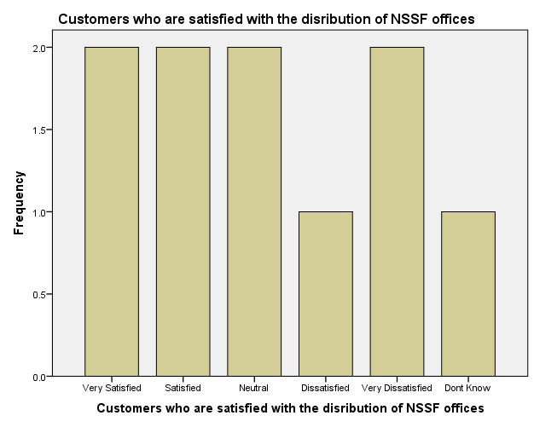

Customers who are satisfied with the registration process

Statistics
Customers who are satisfied with the registration process
N | Valid | 10
N | Missing | 0

Customers who are satisfied with the registration process
 |  | Frequency | Percent | Valid Percent | Cumulative Percent
Valid | Very Satisfied | 1 | 10.0 | 10.0 | 10.0
Valid | Satisfied | 2 | 20.0 | 20.0 | 30.0
Valid | Neutral | 2 | 20.0 | 20.0 | 50.0
Valid | Dissatisfied | 1 | 10.0 | 10.0 | 60.0
Valid | Very Dissatisfied | 2 | 20.0 | 20.0 | 80.0
Valid | Dont Know | 2 | 20.0 | 20.0 | 100.0
Valid | Total | 10 | 100.0 | 100.0

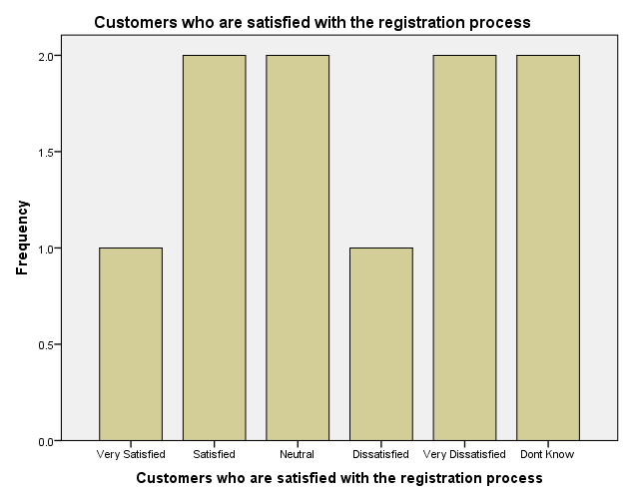

Customers who are satisfied with the modes of contribution to NSSF

Statistics
Customers who are satisfied with the modes of contribution to NSSF
N | Valid | 10
N | Missing | 0

Customers who are satisfied with the modes of contribution to NSSF
 |  | Frequency | Percent | Valid Percent | Cumulative Percent
Valid | Very Satisfied | 2 | 20.0 | 20.0 | 20.0
Valid | Satisfied | 1 | 10.0 | 10.0 | 30.0
Valid | Neutral | 1 | 10.0 | 10.0 | 40.0
Valid | Dissatisfied | 2 | 20.0 | 20.0 | 60.0
Valid | Very Dissatisfied | 2 | 20.0 | 20.0 | 80.0
Valid | Dont Know | 2 | 20.0 | 20.0 | 100.0
Valid | Total | 10 | 100.0 | 100.0

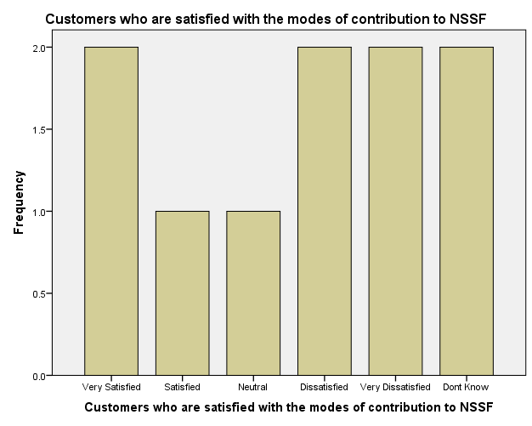

Customers who are satisfied with the affordability of contribution to NSSF

Statistics
Customers who are satisfied with the affordability of contribution to NSSF
N | Valid | 10
N | Missing | 0

Customers who are satisfied with the affordability of contribution to NSSF
 |  | Frequency | Percent | Valid Percent | Cumulative Percent
Valid | Very Satisfied | 1 | 10.0 | 10.0 | 10.0
Valid | Satisfied | 2 | 20.0 | 20.0 | 30.0
Valid | Neutral | 2 | 20.0 | 20.0 | 50.0
Valid | Dissatisfied | 1 | 10.0 | 10.0 | 60.0
Valid | Very Dissatisfied | 2 | 20.0 | 20.0 | 80.0
Valid | Dont Know | 2 | 20.0 | 20.0 | 100.0
Valid | Total | 10 | 100.0 | 100.0

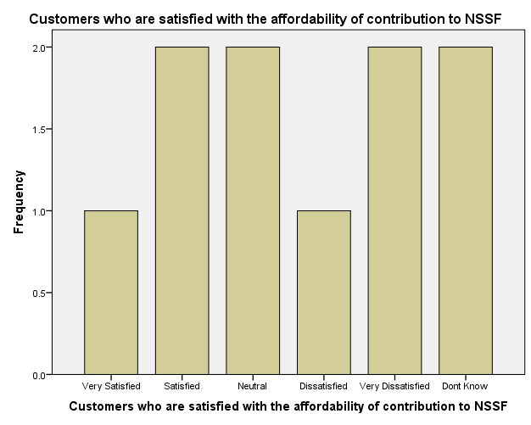

Customers who are satisfied with the contributon sufficient income in the end

Statistics
Customers who are satisfied with the contributon sufficient income in the end
N | Valid | 10
N | Missing | 0

Customers who are satisfied with the contributon sufficient income in the end
 |  | Frequency | Percent | Valid Percent | Cumulative Percent
Valid | Very Satisfied | 2 | 20.0 | 20.0 | 20.0
Valid | Satisfied | 2 | 20.0 | 20.0 | 40.0
Valid | Neutral | 1 | 10.0 | 10.0 | 50.0
Valid | Dissatisfied | 1 | 10.0 | 10.0 | 60.0
Valid | Very Dissatisfied | 2 | 20.0 | 20.0 | 80.0
Valid | Dont Know | 2 | 20.0 | 20.0 | 100.0
Valid | Total | 10 | 100.0 | 100.0

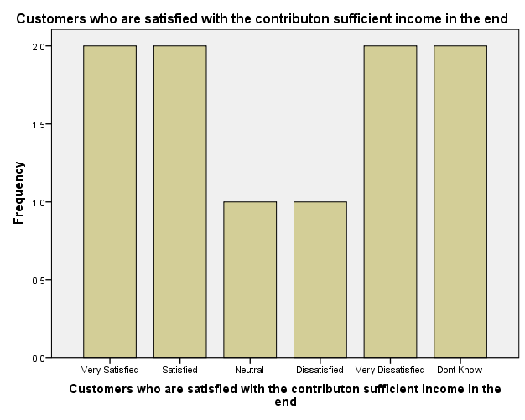

Customers who are satisfied with the safety contributions made to NSSF

Statistics
Customers who are satisfied with the safety contributions made to NSSF
N | Valid | 10
N | Missing | 0

Customers who are satisfied with the safety contributions made to NSSF
 |  | Frequency | Percent | Valid Percent | Cumulative Percent
Valid | Very Satisfied | 1 | 10.0 | 10.0 | 10.0
Valid | Satisfied | 2 | 20.0 | 20.0 | 30.0
Valid | Neutral | 2 | 20.0 | 20.0 | 50.0
Valid | Dissatisfied | 2 | 20.0 | 20.0 | 70.0
Valid | Very Dissatisfied | 1 | 10.0 | 10.0 | 80.0
Valid | Dont Know | 2 | 20.0 | 20.0 | 100.0
Valid | Total | 10 | 100.0 | 100.0

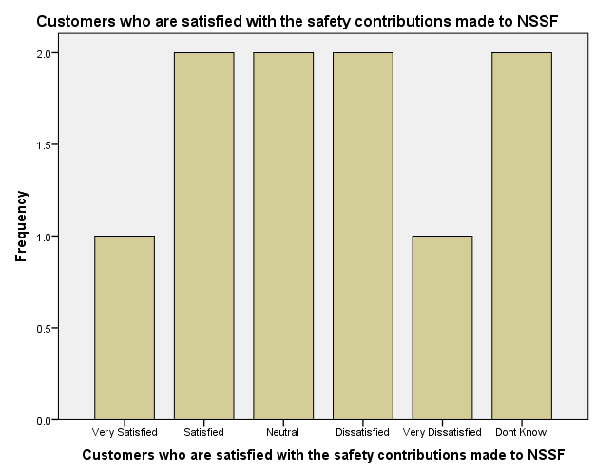

Customers who are satisfied with the investment made by NSSF

Statistics
Customers who are satisfied with the investment made by NSSF
N | Valid | 10
N | Missing | 0

Customers who are satisfied with the investment made by NSSF
 |  | Frequency | Percent | Valid Percent | Cumulative Percent
Valid | Very Satisfied | 2 | 20.0 | 20.0 | 20.0
Valid | Satisfied | 2 | 20.0 | 20.0 | 40.0
Valid | Neutral | 2 | 20.0 | 20.0 | 60.0
Valid | Dissatisfied | 1 | 10.0 | 10.0 | 70.0
Valid | Very Dissatisfied | 2 | 20.0 | 20.0 | 90.0
Valid | Dont Know | 1 | 10.0 | 10.0 | 100.0
Valid | Total | 10 | 100.0 | 100.0

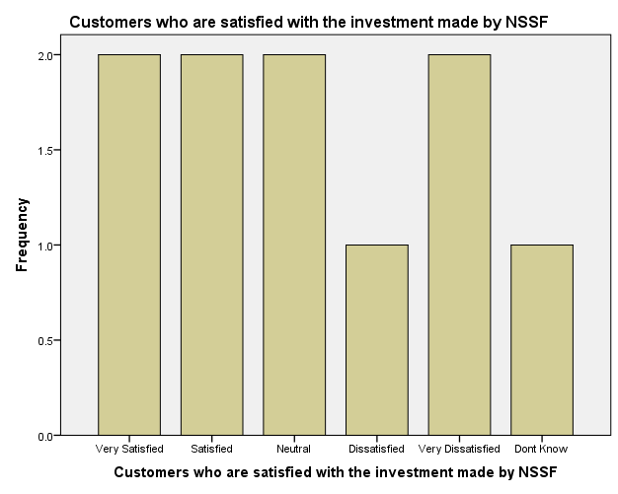

Customers who are satisfied with the NSSF benefits

Statistics
Customers who are satisfied with the NSSF benefits
N | Valid | 10
N | Missing | 0

Customers who are satisfied with the NSSF benefits
 |  | Frequency | Percent | Valid Percent | Cumulative Percent
Valid | Very Satisfied | 1 | 10.0 | 10.0 | 10.0
Valid | Satisfied | 2 | 20.0 | 20.0 | 30.0
Valid | Neutral | 2 | 20.0 | 20.0 | 50.0
Valid | Dissatisfied | 2 | 20.0 | 20.0 | 70.0
Valid | Very Dissatisfied | 1 | 10.0 | 10.0 | 80.0
Valid | Dont Know | 2 | 20.0 | 20.0 | 100.0
Valid | Total | 10 | 100.0 | 100.0

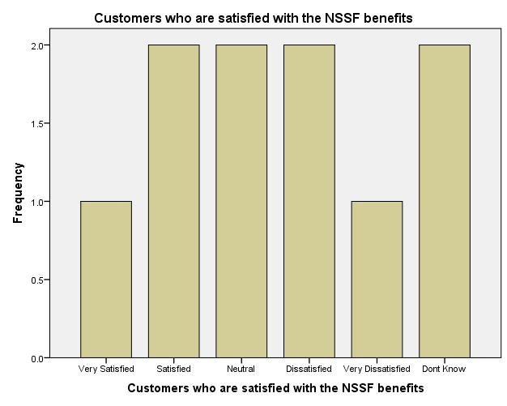

Customers who are satisfied with the rules and decisions exercised by NSSF staff

Statistics
Customers who are satisfied with the rules and decisions exercised by NSSF staff
N | Valid | 10
N | Missing | 0

Customers who are satisfied with the rules and decisions exercised by NSSF staff
 |  | Frequency | Percent | Valid Percent | Cumulative Percent
Valid | Very Satisfied | 2 | 20.0 | 20.0 | 20.0
Valid | Satisfied | 2 | 20.0 | 20.0 | 40.0
Valid | Neutral | 2 | 20.0 | 20.0 | 60.0
Valid | Dissatisfied | 1 | 10.0 | 10.0 | 70.0
Valid | Very Dissatisfied | 2 | 20.0 | 20.0 | 90.0
Valid | Dont Know | 1 | 10.0 | 10.0 | 100.0
Valid | Total | 10 | 100.0 | 100.0

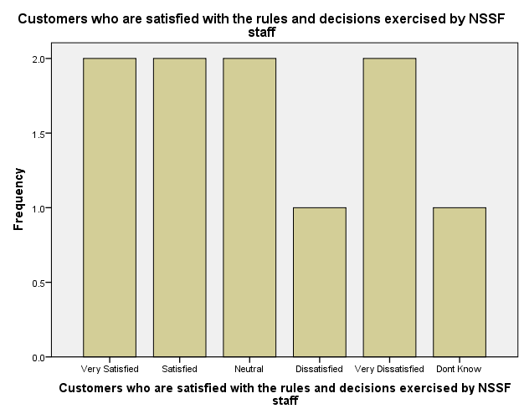

NSSF does not tolerate corrupt activities

Statistics
NSSF does not tolerate corrupt activities
N | Valid | 10
N | Missing | 0

NSSF does not tolerate corrupt activities
 |  | Frequency | Percent | Valid Percent | Cumulative Percent
Valid | Strongly Agree | 2 | 20.0 | 20.0 | 20.0
Valid | Disagree | 2 | 20.0 | 20.0 | 40.0
Valid | Neither Agree Nor | 2 | 20.0 | 20.0 | 60.0
Valid | Agree | 1 | 10.0 | 10.0 | 70.0
Valid | Dont Know | 1 | 10.0 | 10.0 | 80.0
Valid | Strongly Disagree | 2 | 20.0 | 20.0 | 100.0
Valid | Total | 10 | 100.0 | 100.0

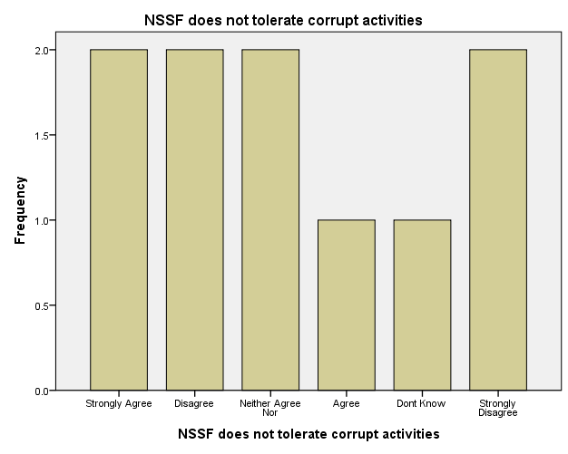

Staff come up with new or better ways of delivering service

Statistics
Staff come up with new or better ways of delivering service
N | Valid | 10
N | Missing | 0

Staff come up with new or better ways of delivering service
 |  | Frequency | Percent | Valid Percent | Cumulative Percent
Valid | Strongly Agree | 2 | 20.0 | 20.0 | 20.0
Valid | Disagree | 2 | 20.0 | 20.0 | 40.0
Valid | Neither Agree Nor | 2 | 20.0 | 20.0 | 60.0
Valid | Agree | 2 | 20.0 | 20.0 | 80.0
Valid | Dont Know | 1 | 10.0 | 10.0 | 90.0
Valid | Strongly Disagree | 1 | 10.0 | 10.0 | 100.0
Valid | Total | 10 | 100.0 | 100.0

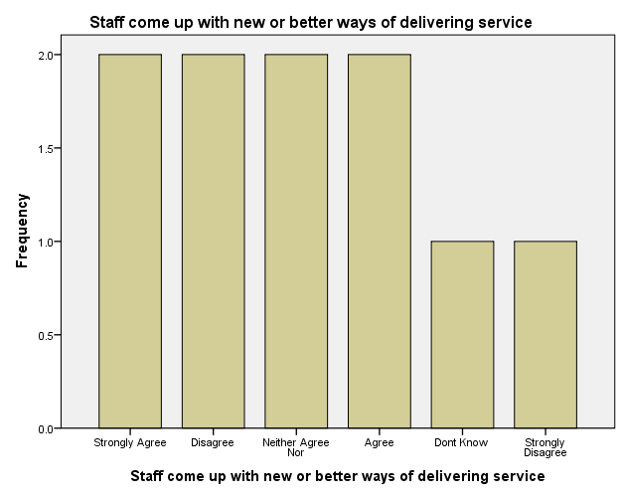

NSSF staff act responsible and openly in their day to day work

Statistics
NSSF staff act responsible and openly in their day to day work
N | Valid | 10
N | Missing | 0

NSSF staff act responsible and openly in their day to day work
 |  | Frequency | Percent | Valid Percent | Cumulative Percent
Valid | Strongly Agree | 1 | 10.0 | 10.0 | 10.0
Valid | Disagree | 1 | 10.0 | 10.0 | 20.0
Valid | Neither Agree Nor | 2 | 20.0 | 20.0 | 40.0
Valid | Agree | 2 | 20.0 | 20.0 | 60.0
Valid | Dont Know | 2 | 20.0 | 20.0 | 80.0
Valid | Strongly Disagree | 2 | 20.0 | 20.0 | 100.0
Valid | Total | 10 | 100.0 | 100.0

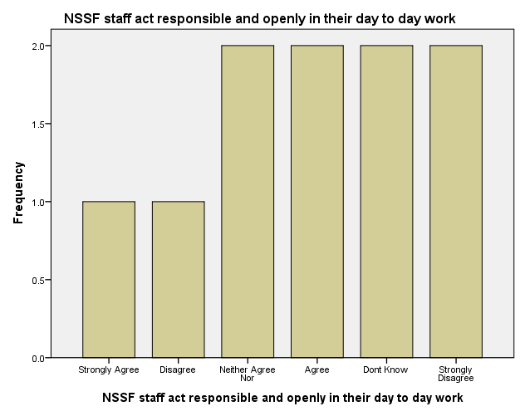

NSSF staff work together when necessary to meet my needs

Statistics
NSSF staff work together when necessary to meet my needs
N | Valid | 10
N | Missing | 0

NSSF staff work together when necessary to meet my needs
 |  | Frequency | Percent | Valid Percent | Cumulative Percent
Valid | Strongly Agree | 1 | 10.0 | 10.0 | 10.0
Valid | Disagree | 3 | 30.0 | 30.0 | 40.0
Valid | Neither Agree Nor | 1 | 10.0 | 10.0 | 50.0
Valid | Agree | 2 | 20.0 | 20.0 | 70.0
Valid | Dont Know | 1 | 10.0 | 10.0 | 80.0
Valid | Strongly Disagree | 2 | 20.0 | 20.0 | 100.0
Valid | Total | 10 | 100.0 | 100.0

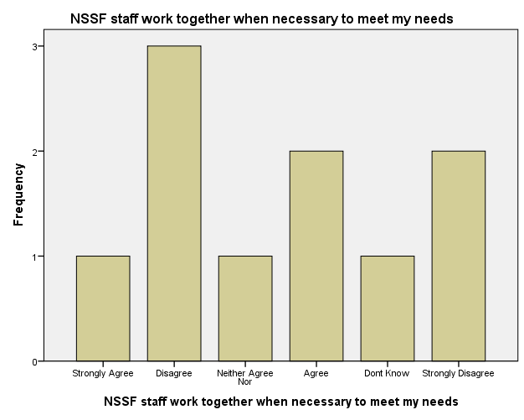

Multiple Response

Notes
Output Created |  | 21-OCT-2022 20:13:13
Comments
Input | Data | C:\Users\ABDIRIZAK\Desktop\ABDIRIZAK.sav
Input | Active Dataset | DataSet0
Input | Filter | <none>
Input | Weight | <none>
Input | Split File | <none>
Input | N of Rows in Working Data File | 10
Missing Value Handling | Definition of Missing | User-defined missing values are treated as missing.
Missing Value Handling | Cases Used | Statistics for each table are based on all the cases with valid data in the specified range(s) for all variables in each table.

Notes
Syntax |  | MULT RESPONSE GROUPS=$Mission_And_Core_Values 'Mission and core values' (radio tv newspaper friends_relatives_colleagues publicityboards employer visiting_their_premises other retirement_benefit survival_benefit invalidity_benefit funeral_grant  emigration_benefit withdrawal_benefit source_radio source_tv source_newspaper source_friends source_publicity_boards source_employer source_visiting_their_premises source_of_other (0))  /FREQUENCIES=$Mission_And_Core_Values.
Resources | Processor Time | 00:00:00.00
Resources | Elapsed Time | 00:00:00.01

Case Summary
 | Cases
 | Valid |  | Missing |  | Total
 | N | Percent | N | Percent | N | Percent
$Mission_And_Core_Valuesª | 10 | 100.0% | 0 | 0.0% | 10 | 100.0%

a. Dichotomy group tabulated at value 0.

$Mission_And_Core_Values Frequencies
 |  | Responses |  | Percent of Cases
 |  | N | Percent | Percent of Cases
Mission and core valuesª | Customers who were aware about NSSF through Radio | 6 | 5.4% | 60.0%
Mission and core valuesª | Customers who were aware about NSSF through TV | 3 | 2.7% | 30.0%
Mission and core valuesª | Customers who were aware about NSSF through Newspaper | 5 | 4.5% | 50.0%
Mission and core valuesª | Customers who were aware about NSSF through Friends/Relatives/Colleagues | 5 | 4.5% | 50.0%
Mission and core valuesª | Customers who were aware about NSSF through Publicityboards | 6 | 5.4% | 60.0%
Mission and core valuesª | Customers who were aware about NSSF through Employer | 6 | 5.4% | 60.0%
Mission and core valuesª | Customers who were aware about NSSF through visiting their premises | 6 | 5.4% | 60.0%
Mission and core valuesª | Customers who were aware about NSSF through other ways | 4 | 3.6% | 40.0%
Mission and core valuesª | Which NSSF benefits are you aware of | 5 | 4.5% | 50.0%
Mission and core valuesª | Which NSSF benefits are you aware of | 6 | 5.4% | 60.0%
Mission and core valuesª | Which NSSF benefits are you aware of | 5 | 4.5% | 50.0%
Mission and core valuesª | Which NSSF benefits are you aware of | 5 | 4.5% | 50.0%
Mission and core valuesª | Which NSSF benefits are you aware of | 5 | 4.5% | 50.0%

$Mission_And_Core_Values Frequencies
 |  | Responses |  | Percent of Cases
 |  | N | Percent | Percent of Cases
Mission and core valuesª | Which NSSF benefits are you aware of | 5 | 4.5% | 50.0%
Mission and core valuesª | Customers who were aware about NSSF product through Radio | 5 | 4.5% | 50.0%
Mission and core valuesª | Customers who were aware about NSSF product through TV | 5 | 4.5% | 50.0%
Mission and core valuesª | Customers who were aware about NSSF product through Newspaper | 5 | 4.5% | 50.0%
Mission and core valuesª | Customers who were aware about NSSF product through Friends | 5 | 4.5% | 50.0%
Mission and core valuesª | Customers who were aware about NSSF product through Publicity boards | 5 | 4.5% | 50.0%
Mission and core valuesª | Customers who were aware about NSSF product through Employer | 5 | 4.5% | 50.0%
Mission and core valuesª | Customers who were aware about NSSF product through Visiting their premies | 5 | 4.5% | 50.0%
Mission and core valuesª | Customers who were aware about NSSF product through Other | 5 | 4.5% | 50.0%
Total |  | 112 | 100.0% | 1120.0%

a. Dichotomy group tabulated at value 0.

